DATABASE INDEXING AND CACHING

DATABASE INDEXING :-

It is a data structure technique which is used to quickly locate and access the data in a database.

Importance of indexing :-

- Indexes are used to quickly locate data without having to search every row in a database table every time a database table is accessed.

- In simple terms index is used to speed up searches/queries.

Create index in postgres :-

CREATE INDEX index_name ON table_name(field_name)
Perform Query:-

select * from table_name where field_name = ‘any_field_data’

Query execute time :-

explain select * from table_name where field_name =’any_field_data’

Delete index in postgres :-

drop index index_name

Suport index datatype in postgres :-

- PostgreSQL provides several index types: B-tree, Hash, GiST, SP- GiST, GIN and BRIN.

- Each index type uses a different algorithm that is best suited to different types of queries.

- By default, the CREATE INDEX command creates B-tree indexes which fit the most common situations.

Gist Indexing in postgres :-

- GiST stands for Generalized Search Tree. It is a balanced, tree- structured access method, that acts as a base template in which to implement arbitrary indexing schemes. B+-trees,R-trees and many other indexing schemes can be implemented in GiST.

Create index:- 1. create extension pg_trgm
2. CREATE INDEX index_name ON table_name USING gist(field_name gist_trgm_ops)
B-Tree indexing in postgres :-
- PostgreSQL B-Tree indexes are multi-level tree structures, where each level of the tree can be used as a doubly-linked list of pages. A single metapage is stored in a fixed position at the start of the first segment file of the index. All other pages are either leaf pages or internal pages.
B-trees can handle equality and range queries on data that can be sorted into some ordering.

---CREATE INDEX index_name ON table_name(field_name)

BRIN indexing in postgres :-

- A BRIN is a Block Range Index. A block is Postgres' base unit of storage and is by default 8kB of data.

- BRIN samples a range of blocks (default 128), storing the location of the first block in the range as well as the minimum and maximum values for all values in those blocks.

- it’s very useful for ordered data sets, offering significant space savings for similar and sometimes better performance.

-- CREATE INDEX index_name ON table_name USING BRIN(field_name)

Hash indexing in postgres :-

- When it comes to space, the Hash index is superior to the B-Tree index, since a Hash index is flat in structure and a B-Tree, as the name implies, has a tree structure. Depending on circumstances, this gain in space can be a real benefit.

-- CREATE INDEX index_name ON table_name USING HASH(field_name)

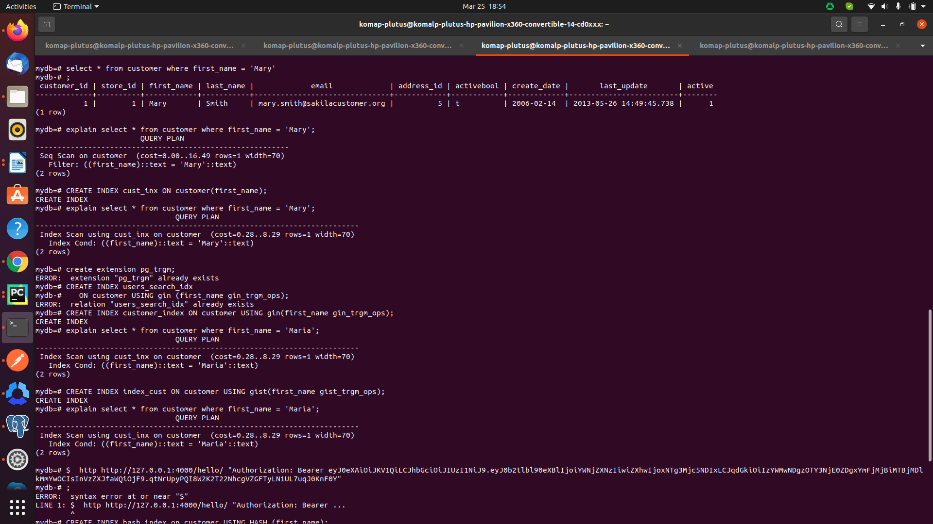
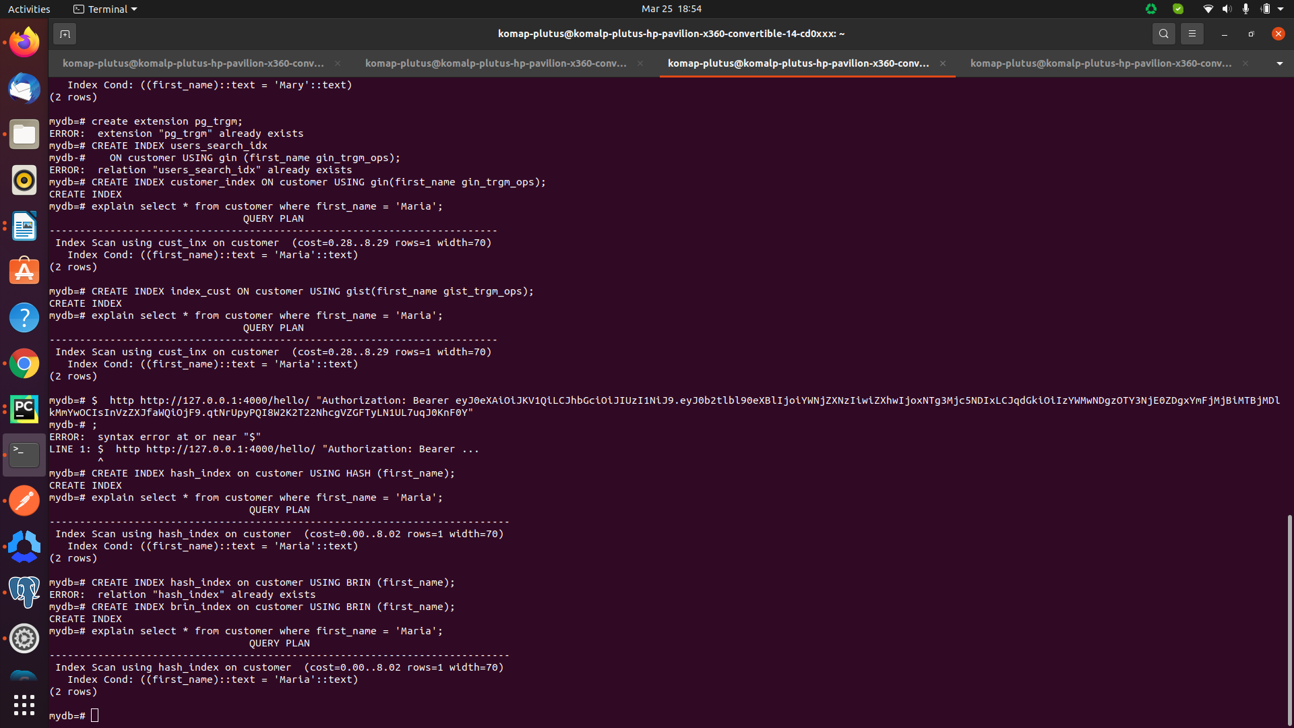

Supportd datatype in postgres :-

Boolean,
Character- [ such as char, varchar, and text]
Numeric- [ such as integer and floating-point number]
Temporal- [ such as date, time, timestamp, and interval]
UUID- [ for storing UUID (Universally Unique Identifiers) ]
Array- [ for storing array strings, numbers, etc.]
JSON- [ stores JSON data]
hstore- [ stores key-value pair]
Special- [ such as network address and geometric data]

DATABASE CACHING :-

- A database cache is a system that caches (saves) results from a database, in order to return the result faster next time.

- It is a process included in the design of computer applications which generate web pages on-demand (dynamically) by accessing backend databases.

- A database cache supplements your primary database by removing unnecessary pressure on it, typically in the form of frequently accessed read data. The cache itself can live in a number of areas including your database, application or as a standalone layer.

- A cache is used to avoid quering a database to much.

- By using database caching ,the function or functions most popularly used are saved into memory , so they can be recalled with ease.

- It is used to reduce time for computer needs to load the database.

- administrator must do dabase caching manually.

- Caching can be applied to any type of database including relational databases such as Amazon RDS or NoSQL databases such as Amazon DynamoDB, MongoDB and Apache Cassandra. The best part of caching is that it’s minimally invasive to implement and - by doing so, your application performance regarding both scale and speed is dramatically improved.
This type of data store in cache memory :-
- Cache memory is a small-sized type of volatile computer memory that provides high-speed data access to a processor and stores frequently used computer programs, applications and data.

Limit of cache memory :-

- The maximum theoretical cache size is 2 GB. The size of cache you can specify is limited by the amount of physical memory and paging space available to the system. The shared class cache consists of memory mapped files that are created on disk and remain when the operating system is restarted.

Types Of Database Caching :-

1. Database integrated Cache :- The integrated cache provides in- memory storage on the Citrix ADC appliance and serves Web content to users without requiring a round trip to an origin server.

2. Local Cache :- A local cache stores your frequently used data within your application. This not only speeds up your data retrieval but also removes network traffic associated with retrieving data, making data retrieval faster than other caching architectures.

3. Remote Cache :- Remote caching is a scalable, high-performance remote file data access function across a wide area network (WAN) that is integrated with General Parallel File System (GPFS™). You can use remote caching to distribute data transparently among data centers and multiple remote locations without disrupting the applications.

Remote caches are stored on dedicated servers and typically built upon key/value NoSQL stores such as Redis and Memcached.

They provide hundreds of thousands to up-to a million requests per
cache node. Many solutions such as Amazon ElastiCache for Redis also provide the high availability needed fro critical workloads.

4.Internal cache: It’s keeping things ready that it thinks you might need, based on usage patterns. You have no influence on this.

5.Query cache: If you make a query more than once (for instance for a user profile), the result is cached and returned from RAM instead. When the alotted RAM runs out, the least recently used query is deleted to make space for new ones. When the underlying data changes, either on a table or row/document level, depending on the database, the cache is cleared.

CACHING FOR POSTGRES:-

defination:-Data caching in PostgreSQL is not suitable or we can say not pre- allocated and it can be calculated only and it depends on workload. The main purpose of caching in PostgreSQL is to increase the performance of the server.

The caching means when we execute a query it goes from different stages in which there is one stage we called the planning stage. In the planning stage, we select the best and suitable plan for query - execution.

Caching is temporary memory and it is used to increase the performance of query as well as the server. Cache is allocated per query execution plan once the query is executed then the cache is vanished.

Syntax :- explain(analyze,buffers) select * from table name order by column name limit;

Caching Works in postgres :- PostgreSQL process based on the system that is when the PostgreSQL process requests for any access through SQL query statement at that time PostgreSQL requests for the buffer allocation. If the memory block is available then it directly returns the result. If a memory block is not available then it goes for buffer allocation to get a free block for query execution.
Improve performance of caching in postgres :-
Example :-
1.create table empp (emp_id serial PRIMARY KEY, emp_name varchar(30), emp_dept varchar[],emp_city varchar[],emp_salary text[]);
2.Insert into empp (emp_name, emp_dept, emp_city, emp_salary) Values ('Jacson','{"comp"}' , '{"City W"}', '{"40000"}'), ('Paul', '{"mech"}', '{"City A"}', '{"20000"}'), ('sam', '{"Account"}','{"City B"}','{"10000"}'), ('John', '{"Purchase"}', '{"City C"}','{"30000"}');
select * from empp;
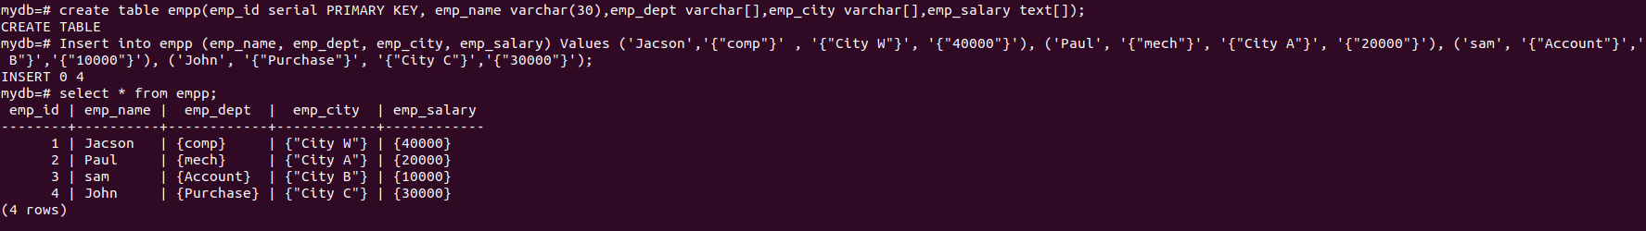
3. explain (analyze,buffers) select * from empp order by emp_salary limit 2;
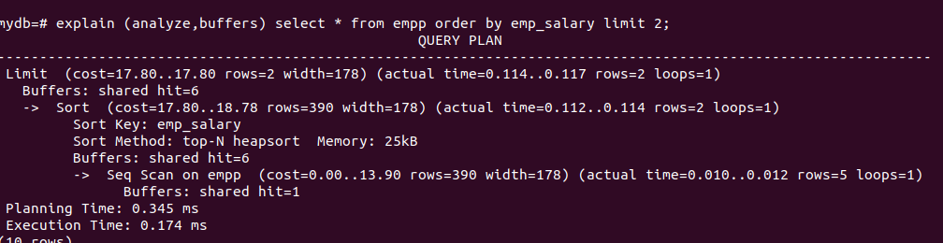

1. Bottleneck situation in the query performance
Before discussing the solution to the above problem let’s understand why queries are slow. The first reason is the performance of your system. That means when we run an application on a system at that time we check the performance of the system. For that instance, any CPU or network bottleneck may occur that affect your process means fetching data from the database. The solution for that problem is to check the health of your system regularly and for bottleneck increase or scale up the database size.
2. Internal Cache Performance
Internal cache performance means the hit rate of the database table. Sometimes the hit rate of the database table is low due to insufficient internal buffer space of the database this is the main reason of the table hit rate is low. So in PostgreSQL, we use the shared buffer concept to avoid a low rate of database table. A shared buffer is used to manage the buffer space of a database.
Just for knowledge - Shared buffer in Postgres :-
A database server also needs memory for quick access to data, whether it is READ or WRITE access. In PostgreSQL, this is referred to as "shared buffers" and is controlled by the parameter shared_buffers. The amount of RAM required by shared buffers is always locked for the PostgreSQL instance during its lifetime.

CACHING IN DJANGO

1. Django RedisCache :-

Redis :- Redis is an in-memory data structure store that can be used for caching . Since it keeps data in RAM, Redis can deliver it very quickly. Redis is not the only product that we can use for caching.

Installation redis in ubuntu :-
sudo apt-get update
sudo apt-get install redis

Exploring redis with cli :-
$ redis-cli ping
PONG
$ redis-cli

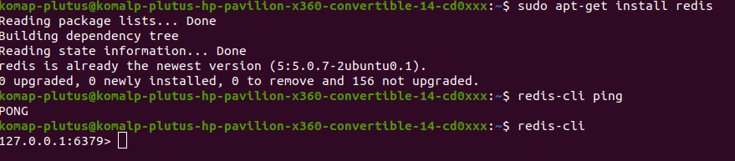

After setting up the Redis server, you’ll need to install Python bindings for Redis.

Installation redis in django :-

pip install django_redis
To use Redis as your cache backend with Django:
- Set BACKEND to django.core.cache.backends.redis.RedisCache.
- Set LOCATION to the URL pointing to your Redis instance, using the appropriate scheme.

CACHES = {
'default': {
'BACKEND': 'django.core.cache.backends.redis.RedisCache',
'LOCATION': 'redis://127.0.0.1:6379',
}
}
settings.py
add:- your app name in INSTALLED_APP
add:-
CACHE_TTL = 60 * 1500
CACHES = {
"default": {
"BACKEND": "django.core.cache.backends.redis.RedisCache",
"LOCATION": "redis://127.0.0.1:6379",

}
}

Models.py
from django.db import models

class Recipe(models.Model):
name = models.CharField(max_length=100)
desc = models.TextField()

def __str__(self):
return self.name

Views.py
from django.shortcuts import render
from django.shortcuts import render
from .models import *
from django.conf import settings
from django.core.cache.backends.base import DEFAULT_TIMEOUT
from django.views.decorators.cache import cache_page
from django.core.cache import cache

CACHE_TTL = getattr(settings, 'CACHE_TTL', DEFAULT_TIMEOUT)

def get_recipe(filter_recipe=None):
if filter_recipe:
print("DATA COMING FROM DB")

recipes = Recipe.objects.filter(name__contains=filter_recipe)
else:
recipes = Recipe.objects.all()
return recipes

def home(request):
filter_recipe = request.GET.get('recipe')
if cache.get(filter_recipe):
print("DATA COMING FROM CACHE")
recipe = cache.get(filter_recipe)
else:
if filter_recipe:
recipe = get_recipe(filter_recipe)
cache.set(filter_recipe, recipe)
else:
recipe = get_recipe()

context = {'recipe': recipe}
return render(request, 'home.html', context)

def show(request, id):
if cache.get(id):
print("DATA COMING FROM CACHE")
recipe = cache.get(id)
else:
print("DATA COMING FROM DB")

recipe = Recipe.objects.get(id=id)
cache.set(id, recipe)
context = {'recipe': recipe}
return render(request, 'show.html', context)
Urls.py
from django.contrib import admin
from django.urls import path, include
from .views import *
urlpatterns = [
path('', home, name='home'),
path('<int:id>', show, name='show'),
]
Home.html
<!DOCTYPE html>
<html lang="en">
<head>
<meta charset="UTF-8">
<meta name="viewport" content="width=device-width, initial-scale=1.0">
<title>Document</title>
</head>
<body>
<div class="container mt-5">
<form method="get">
<div class="mx-auto text-center d-flex ">
<input class="form-control" name="recipe" placeholder="Search" style="width:400px">
<button class="btn btn-primary">Search</button>
</div>
</form>
</div>
<div class="container mt-5">
{% if recipe %}
<table>
<thead>
<tr>
<th style="width:30%">Recipe Name</th>
<th style="width:40%">Description</th>
<th style="width:30%">View</th>
</tr>
</thead>
<tbody>
{% for r in recipe %}
<tr class="pt-4">
<td>{{r.name}}</td>
<td>{{r.desc|truncatechars:250}}</td>
<td><a href="{{r.id}}" class="btn btn-success">View</a></td>
</tr>
{% endfor %}
<hr>
</tbody>
</table>
{% else %}
<p class="text-center"> No recipe found.. Try something else</p>
{% endif %}
</div>
<footer class="bg-dark p-2 mt-5">
<p class="text-center text-white">Django Redis</p>
</footer>

</body>
</html>
Show.html
<!DOCTYPE html>
<html lang="en">
<head>
<meta charset="UTF-8">
<meta name="viewport" content="width=device-width, initial-scale=1.0">
<title>Document</title>
</head>
<body>
<div class="container-fluid mt-5">
<a href="/" class="btn btn-danger">Back</a>
<h1 class="mt-4">{{recipe.name}}</h1>
<p>{{recipe.desc}}</p>
</div>
</body>
</html>
2. Django Memcache :-
MemCache :- Memcached is an open source, distributed memory object caching system that alleviates database load to speed up dynamic Web applications. The system caches data and objects in memory to minimize the frequency with which an external database or API (application program interface) must be accessed.
Memcache is an in-memory key-value store for small chunks of arbitrary data(string,objects) from result of database calls,API calls,page rendering.
Installation memcache in ubuntu :-
sudo apt update
sudo apt-get install memcached

- also install libmemcached-tools, which is a package that contains various tools that you can use to examine, test, and manage Memcached server.

sudo apt install memcached libmemcached-tools

- Once the installation is completed, the memcached service will start automatically. To check the status of the service

sudo systemctl status memcached
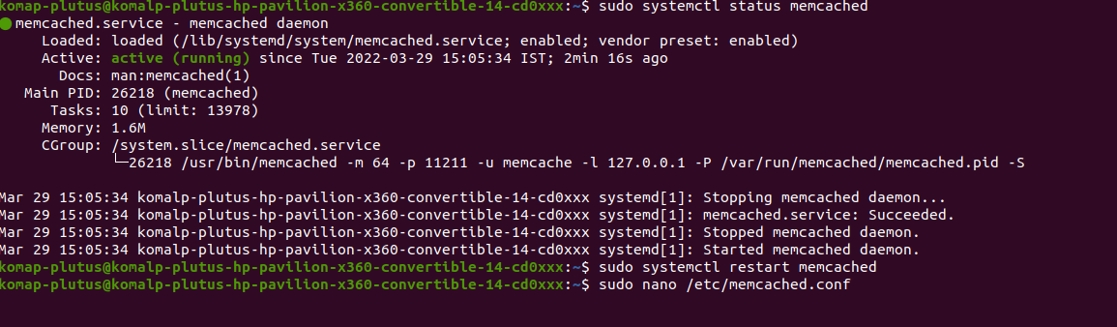

Configuring Memcached
- Memcached options can be configured in the /etc/memcached.conf file. By default, memcached is set to listen only on localhost.
The default configuration settings are sufficient for most users.

Remote Access
- If the client connecting to memcached is running on the same host, you should not allow remote access.
When improperly configured, memcached can be used to perform a distributed denial-of-service (DDoS) attack. To alloow remote access to the memcached server, you need to configure the firewall and open the memcached UDP port 11211 only from trusted clients.
sudo nano /etc/memcached.conf
now, replace 127.0.0.1 with the server IP address 192.168.100.20.
IN /etc/memcached.conf
-l 192.168.100.20
Here 192.168.100.20 is memcached server IP
sudo systemctl restart memcached
sudo ufw allow from 192.168.100.30 to any port 11211
Installation memcache in django :-
pip install pymemcache
pip install python-memcached

just for knowledge:- check memcached running on system memcached -vv

To use Memcached with Django:

set BACKEND to django.core.cache.backends.memcached.PyMemcacheCache
- Set LOCATION to ip:port values, where ip is the IP address of the Memcached daemon and port is the port on which Memcached is running.
CACHES = {
'default’: {
'BACKEND': 'django.core.cache.backends.memcached.PyMemcacheCache',
'LOCATION': '127.0.0.1:11211',
}
}
Settings.py
CACHES = {
'default': {
'BACKEND': 'django.core.cache.backends.memcached.PyMemcacheCache',
'LOCATION': '127.0.0.1:11211',
}
}
Models.py
from django.db import models
class Movie(models.Model):
name = models.CharField(max_length=100)
desc = models.TextField()
image = models.CharField(max_length=400)
ticket_price=models.PositiveIntegerField()
def __str__(self):
return self.name
Views.py
from django.shortcuts import render
from django.shortcuts import render, redirect, reverse
from django.http import HttpResponse
from .models import *
from django.conf import settings
from django.core.cache.backends.base import DEFAULT_TIMEOUT
from django.views.decorators.cache import cache_page
from django.core.cache import cache
from .forms import *
CACHE_TTL = getattr(settings, 'CACHE_TTL', DEFAULT_TIMEOUT)
def get_movie(filter_recipe=None):
if filter_movie:
print("DATA COMING FROM DB")

movie = Movie.objects.filter(name__contains=filter_movie)
else:
movie = Movie.objects.all()
return movie
def get_create(request):
context = {}
context["form"] = MovieForm()
if request.method == "POST":
form = MovieForm(request.POST)
if form.is_valid():
form.save()
return redirect(reverse("home"))
else:
context["form"] = form
return render(request, "movie.html", context)
return render(request, "movie.html", context)
def home(request):
filter_movie = request.GET.get('movie')
if cache.get(filter_movie):
print("DATA COMING FROM CACHE")
movie = cache.get(filter_movie)
else:
if filter_movie:
movie = get_recipe(filter_movie)
cache.set(filter_movie, movie)
else:
movie = get_movie()

context = {'movie': movie}
return render(request, 'home.html', context)
def show(request, id):
if cache.get(id):
print("DATA COMING FROM CACHE")
movie = cache.get(id)
else:
print("DATA COMING FROM DB")
movie = Movie.objects.get(id=id)
cache.set(id, movie)
context = {'movie': movie}
return render(request, 'show.html', context)
3. Django FileSystem Caching :-
FileSystem :- The file system cache holds data recently that was read from the disk, making it possible for subsequent requests to obtain data from cache rather than to read it again from the disk. Because memory access is many times faster than disk access, leaving some physical memory available for the file system cache can boost performance.
he file-based backend serializes and stores each cache value as a separate file. To use this backend set BACKEND to "django.core.cache.backends.filebased.FileBasedCache" and LOCATION t o a suitable directory. For example, to store cached data in /var/tmp/django_cache, use this setting:
CACHES = {
'default': {
'BACKEND': 'django.core.cache.backends.filebased.FileBasedCache',
'LOCATION': '/var/tmp/django_cache',
}
}

4. local-Memory Caching :-
- save cache data in local server
This is the default cache if another is not specified in your settings file. If you want the speed advantages of in-memory caching but don’t have the capability of running Memcached, consider the local-memory cache backend. This cache is per-process (see below) and thread-safe. To use it, set BACKEND to "django.core.cache.backends.locmem.LocMemCache". For example:
CACHES = {
'default': {
'BACKEND': 'django.core.cache.backends.locmem.LocMemCache',
'LOCATION': 'unique-snowflake',
}
}
5. Django DatabaseCache :-

- Django comes with its own caching system that lets you save your dynamic pages, to avoid calculating them again when needed.

- The good point in Django Cache framework is that you can cache output of a specific view. A part of a template.

- Django can store its cached data in your database. This works best if you’ve got a fast, well-indexed database server.

Set BACKEND to django.core.cache.backends.db.DatabaseCache

CACHES = {
’default’: {
'BACKEND': 'django.core.cache.backends.db.DatabaseCache',
'LOCATION': 'table_name',
}
}
Per-site FileSystemCache, Local-memoryCache & DatabaseCache :-
The Per-site Cache – Once The cache is set up ,the simplest way to use caching is to cache your entire site.
Settings.py
DATABASES = {
'default': {
'ENGINE': 'django.db.backends.postgresql_psycopg2',
'NAME': 'cachedb',
'USER': 'postgres',
'PASSWORD': 'root',
'HOST': 'localhost',
'PORT': '',
}
}
Settings.py/middleware
'django.middleware.cache.UpdateCacheMiddleware',
'django.middleware.cache.FetchFromCacheMiddleware',
CACHE_MIDDLEWARE_SECOND = 60
‘’’For Local-memoryCache’’’
CACHES = {
'default': {
'BACKEND': 'django.core.cache.backends.locmem.LocMemCache',
'LOCATION': 'unique-snowflake',
}
}
‘’’For FileSystemCache ‘’’
CACHES = {
'default': {
'BACKEND': 'django.core.cache.backends.filebased.FileBasedCache',
'LOCATION': '/home/komap-plutus/Desktop/Django_Persite_Filesystem/Dpsf/cache',
}
}
‘’’ For DatabaseCache ‘’’
CACHES = {
'default': {
'BACKEND': 'django.core.cache.backends.db.DatabaseCache',
'LOCATION': 'myapp_cache',
}
}
Models.py
from django.db import models
class Family(models.Model):
name = models.CharField(max_length=40)
Views.py
from django.shortcuts import render
def home(request):
return render(request, 'enroll/course.html')
Urls.py
from django.urls import path
from .views import *
urlpatterns = [
path('', home, name='home')
]
Course.html
<!doctype html>
<html lang="en">
<head>
<meta charset="UTF-8">
<meta name="viewport"
content="width=device-width, user-scalable=no, initial-scale=1.0, maximum-scale=1.0, minimum-scale=1.0">
<meta http-equiv="X-UA-Compatible" content="ie=edge">
<title>Document</title>
</head>
<body>
<h1>Course 1</h1>
<h1>Course 2</h1>
<h1>FileSystemCache</h1>
</body>
</html>
Per-view FileSystemCache,Local-memoryCache & DatabaseCache
The Per-view Cache :- A more granular way to use the caching framework is by caching the output of individual views.
Same as a per-site cache , but you need to just some changes only on view file and you don’t add 'django.middleware.cache.UpdateCacheMiddleware','django.middleware.cache.FetchFromCacheMiddleware', in settings.py file
Views.py
from django.shortcuts import render
from django.views.decorators.cache import cache_page
# Create your views here.
@cache_page(30)
def home(request):
return render(request, 'enroll/course.html')
def contact(request):
return render(request, 'enroll/course.html')

Template fragment FileSystemCache,Local-memoryCache & DatabaseCache
Template fragment Caching :- This gives you more control what to cache
{% load cache %} - This give access to cache tag in template
{% cache %} - This template tag caches the contents of the block for given amount of time.
Syntax -
{% cache timeout name variable using =” ” %}.......{% endcache name %}
you must be use any cache (filesystem,local,database)
- Same as a per-view cache , but you need to just some changes only on template/course.html file
templates/course.html
<!doctype html>
{% load cache %}
<html lang="en">
<head>
<meta charset="UTF-8">
<meta name="viewport"
content="width=device-width, user-scalable=no, initial-scale=1.0, maximum-scale=1.0, minimum-scale=1.0">
<meta http-equiv="X-UA-Compatible" content="ie=edge">
<title>Document</title>
</head>
<body>
<h1>Course 1</h1>
<h1>Course 204</h1>
{% cache 30 template-cache %}
<h3>template-fragment-cache</h3>
<h3>templateCacheeee</h3>
{% endcache template-cache %}
<h1>Complate Caching</h1>
<h1>Last One but not a list one </h1>
</body>
</html>

